TRƯỜNG ĐẠI HỌC CÔNG NGHỆ THÔNG TIN &

TRUYỀN THÔNG VIỆT  HÀN

**Khoa Khoa Học Máy Tính**



CLOUD COMPUTING (3)

**EXERCISE 4 :**

**NODEJS AND HANDLEBAR**

Sinh viên thực hiện : **Nguyễn Lê Hữu Duy**

**Mai Thanh Trí Đông**

**Nguyễn Chí Hiếu**

**Trần Quang Hiếu**

**Nguyễn Đức Gia Khanh**

Giảng viên hướng dẫn: **Ts. Đặng Quang Hiển**

Đà Nẵng, 01  tháng 09 năm 2023

**TABLE OF CONTENTS**

**1. Installing Express Handlebars** 2

**2. Folder Structure For App and Express Handlebars Templates** 3

**2.1 Views** 3

**2.2 Layouts** 4

**2.3 Partials** 4

**3. Setup Routes and Template Engine Using Handlebars** 4

**4. Using Shared Partials Handlebars Template** 5

## **1. Installing Express Handlebars**

In Node js, we can render HTML template but when it comes to the dynamic part i.e we have some data and that must be bind in the template. where else in normal HTML it becomes tricky to bind data so using a Handlebar JS to build semantic templates.

So let’s first install the required packages.

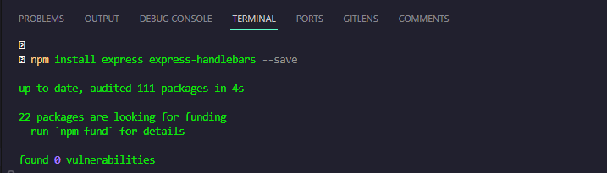

which will install the two packages.

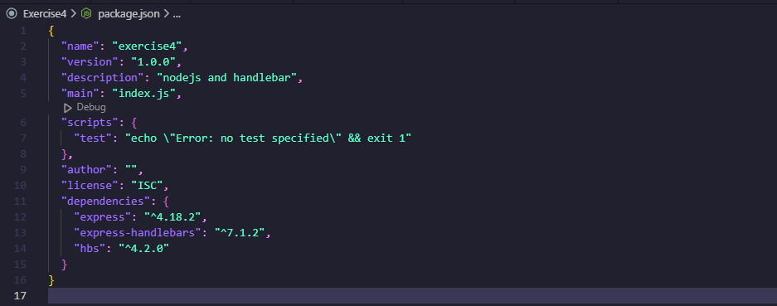

## **2. Folder Structure For App and Express Handlebars Templates**

The next step is needed to define a proper folder structure, As in the package documentation the folder structure is mention like this:

**|-- package.json**

**|-- index.js**

**|-- views**

**| |-- layouts**

**| | |-- main.hbs**

**| |**

**| |-- partials**

**| | |-- header.hbs**

**| | |-- footer.hbs**

**| |**

**| |-- home.hbs**

**| |-- about-us.hbs**

### **2.1 Views**

On the app root level, create a folder name views which will contain all the files regarding the template.

### **2.2 Layouts**

Inside the views folder, there’s will be another folder names as layouts which will contain the index file of the application in which just HTML boilerplate will be added the body content will serve from the views folder’s root template files.

### **2.3 Partials**

Inside the views folder, there’s will be another folder names as partials which will use as a shared template files folder such as header and footer and any other reusable HTML block.

## **3. Setup Routes and Template Engine Using Handlebars**

**Using Handlebars**

At the very first will set our index.js with two basic routes and also will configure the template engine to render or .hbs files.

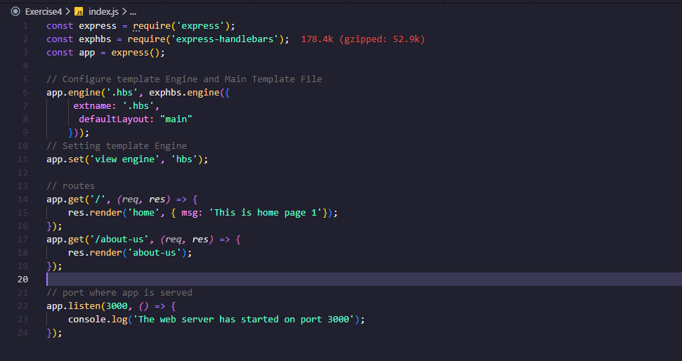

The res.render('home') will render the template name as home.hbs to the assigned route.

Now will setup the template files to make our first index page. so in our views/layouts/ will add HTML boilerplate content to main.hbs file

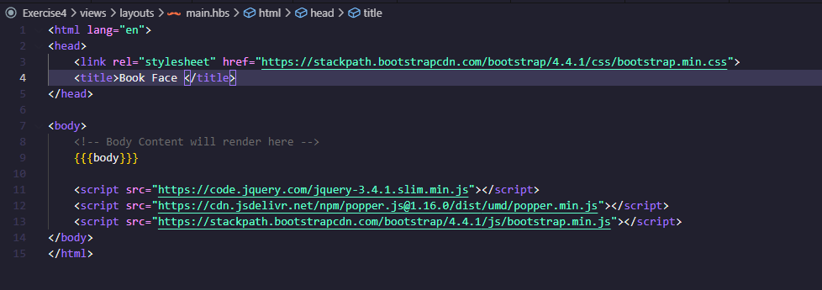

And in the Views folder home.hbs will contain the body part which will render that content into the main.hbs {{{body}}} place

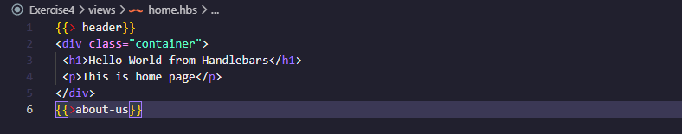

This will render the home content to the base route.

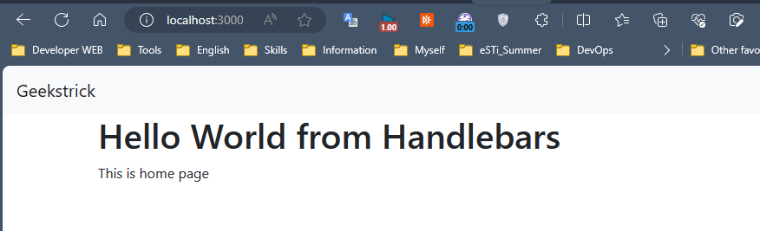

let us see further how can a partials HTML block can be implemented in the template.

## **4. Using Shared Partials Handlebars Template**

Before we use the partial templates lets first put some content inside the header.hbs to use the same header HTML block in both pages i.e. home and about-us page.

using a simple bootstrap navbar example.

